
السيرة الذاتية 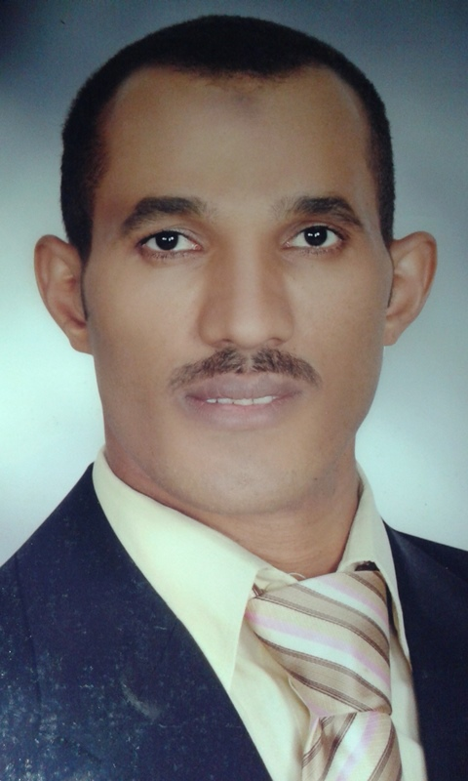

C.V

ــــــــــــــــــــــــــــــــــــــــــــــــــــــــــــــــــــــــــــــــــــــــــــــــــــــــــــــــــــــــــــــــــــــــــــــــــــــــ

Personal data:

Name : Ahmed Mahmoud Mohamed Allam.

Date of birth : 20/1/1983.

Place of birth : Apo Shusha – Apo Tesht – Qena –Egypt.

The current residence: Apo Shusha city Apo Tesht – Qena –Egypt.

The nationality : Egyptian.

The religion : Muslim.

The job : Assistant Lecturer in the Department of Accounting - Faculty of Commerce - University of Assiut - Egypt.

Mobile : 01119057371 – 01003140385.

Marital status : Married.

Military status : Completed.

Email : ahmedallam_2011983 @yahoo.com

ahmedallam_2011983@aun.edu.eg

Qualifications:

* Master in Financial Accounting entitled: "Accounting of assets financing lease operations in the Egyptian business environment" - Asyut University - Egypt, October 2012.

* Bachelor of Commerce. Division of Accounting. Faculty of Commerce - University of Asyut - Egypt (June 2003, very good degree by 87.6% honors degree).

English language skills:
The proficiency in English language through the following courses:

* Level "1" from English Language Center – Assiut University – July, 2004.

* Level "2" from English Language Center – Assiut University - July, 2005.

* Level "5" from the Center For Continuing Education (Assiut) – The American University – March28, 2007.

* TOEFL. ITP. - March, 2011.

Computer Skills:
Proficiency in computer through get the following courses:
* Attending a course of commercial applications and computer accounting (96%, excellent degree )the computer center, the Faculty of Commerce - Asyut University, March 2006.

* Attending a group of computer courses, organized by the Supreme Council of Egyptian Universities during the period from April 2006 to August 2006.
These courses are:

1- Typing. 2- Information Technology
3- Windows Xp 4- Microsoft Word
5- Microsoft Excel 6- Microsoft PowerPoint
7- Internet 8- Hardware
9- Access 10- Photoshop
11- FrontPage

Teaching skills and scientific research:

* Holds a course of "The use of technology in teaching," Development Center for Staff Members – Asyut University, 5 to 7 February 2008.

* Holds a course of "Scientific Publications" Development Center for Staff Members - Asyut University, February 9 to 11, 2008.

* Holds a course "systems of examinations and student assessment" Development Center for Staff Members - Asyut University, 16 to 18 February 2008.

* Holds a course of "strategic planning" Development Center for Staff Members – Asyut University, 17 to 19 January 2009.

* Participation in the fourth scientific conference of Accounting Department, Faculty of Commerce - Cairo University titled: "Modern Trends of accounting and auditing in the light of the economic and technological changes" - June 2007.

* Teaching in the Faculty of Commerce - Asyut University (since 2004 till now), in the following instructions:
- Financial Accounting in individual enterprises.
- Financial Accounting in individual companies.
- Financial Accounting firms in the funds.
- Accounting in financial institutions.
- Intermediate Financial Accounting.
- Advanced Financial Accounting.
- The principles of the audit.
- Review and the role of the auditor.
- Cost-accounting principles.
- Cost Accounting Systems.
- Management Accounting.

Projects:

• Work as a researcher in the project of training and rehabilitation of the graduates in the Faculty of Commerce - University of Asyut to meet the needs of the labor market and the requirements of self-employment - Higher Education Development Fund HEEPE, the summer of 2004.

• Working as a trainer within the program of refresher course for leaders of public and executive within the decentralization initiative in Asyut, which was held in coordination with the Center for Future Studies and USAID, April-May 2007.

• Participating in the work of the Quality Assurance Unit, Faculty of Commerce – Asyut University, 2010/2011.

• Participating in a team internal accounting department at the Faculty of Commerce at the University of Asyut to the characterization of the undergraduate program and report your accounting department.

Voluntary and social work :

• Participation in student activities organized by the families of students at the Faculty of Commerce at the University of Asyut (sports activities, tours, panel discussions, field visits to charities and Oncology Hospital in Assiut, field visits to the Association Afattayat disabilities in Assiut).

• Participation in infinite families MFN Assiut Governorate, in conjunction with the National Center for Social and Criminological Research, March 2007.

• Participation in the activities of some Egyptian Society for the fight against crime , delinquency and the development of Asyut, Summer 2010.

